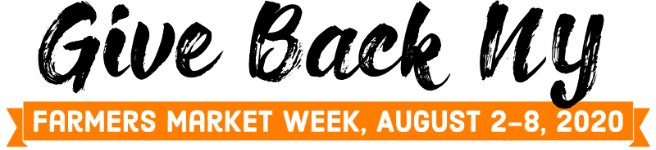

Guidance for Farmers Markets

One of the silver linings of the COVID pandemic is an increased appreciation for local food. Farmers markets have seen a rise in customer participation and sales as people react to a need for healthy, nutritious food and the growing concern over empty supermarket shelves.

We can now give back to our communities, thanking them for their tremendous support for their local farmers and vendors by celebrating National Farmers Market Week with Give Back NY, a week-long celebration that will emphasize donations to local pantries and emergency feeding programs. We will be encouraging consumers and farmers to offer food or fund donations at farmers markets during Farmers Market Week, August 2 – 8.

Our goal is to have farmers markets make connections with local food pantries to invite them to participate in the market during the National Farmers Market Week. Your participation in Give Back NY will allow you to build awareness for hunger in your community and to work with your local food pantry or emergency feeding program to solicit donations to further their mission. The toolkit contains lists of food pantries and emergency food programs from which you can locate the programs in your area to connect with. The Farmers Market Federation has already contacted New York Food Banks asking that they spread the word about Give Back NY to their partner agencies, so your phone call will not be out of the blue. We have let them know that having a presence at farmers markets is their best option for maximizing donations, but also gives them the opportunity to educate market goers about hunger in the community and the role emergency feeding programs play in alleviating hunger.

Also in the toolkit is a series of social media templates, market signage and press releases to be used to showcase Give Back NY and the opportunity to support local food, local farmers and local communities by sharing the bounty!

Invite your local food pantry or emergency feeding program

While we have let Food Banks and their partner agencies know about Give Back NY, the invite to participate in your market needs to come from you.
- Reach out to the food pantries and emergency feeding programs in or around your community. Invite them to participate in your market during National Farmers Market Week, August 2 – 8. 2020. Be sure they know:
  - day and times of your market
  - specific location of your market
  - any special requirements you may have for participating in your market, such as insurance
  - all the safety guidelines they need to follow being at the market
  - whether your market permit allows fundraising (some markets have permits from their local municipality that prohibit fundraising cash or cash equivalent at the market).
- Work with the pantry on how they will be accepting food drive donations, transporting them from the market and what products can be donated. Ie. fresh food purchased from farmers and vendors, end of market day food donations, shelf stable foods. Some food pantries have new rules they follow for accepting donations due to COVID 19. Be sure you ask about those rules and communicate them to your customers so that proper protocols can be followed.

Next you will find a series of press releases and social media posts in the tool kit. These will help you reach consumers in your community, spread awareness of the Give Back NY celebration and encourage people to visit the market during Farmers Market Week, allowing them to donate directly to the food pantry, including suggestions for how donations can be made during Give Back NY.

You will want to promote Give Bank NY for a few weeks leading up to National Farmers Market Week, August 2 -8, to be sure your consumers and farmers are aware and ready to participate.

Can you participate if a food pantry does not want to set up in the market?

You may find that some food pantries will want to participate in Give Back NY, but are not able to set up in the market. If that is the case, you can set up a table in the market, maybe near the manager’s tent, to accept donations. You will need to make arrangements with the pantry to get the donations to them – whether they can pick up from the market at the end of the day or meet you at the pantry to accept delivery. While this will likely not result in the level of donations they would receive if they had a presence in the market, it may be the only way for the pantry to participate.

Note: it is not advisable for markets to collect financial donations on behalf of the food pantry.

Follow up to the event

Can you build on your new found relationship with the food pantry? This is your opportunity to extend an invitation to the food pantry to participate in your market on a more regular basis – monthly, weekly.

The Farmers Market Federation will follow up the event by extending our thanks to our state’s food banks for supporting Give Back NY by providing us with lists of food pantries across the state, and promoting the program to the food pantries and emergency feeding programs in their regions. We would also like to give our thanks to each of the pantries that participated. To do that, we ask that you provide the Farmers Market Federation of NY with the name and contact information for the pantries you worked with. If you take pictures during the event, we ask that you share those pictures with us. Pictures and participating pantries can be sent to the Federation at deggert@nyfarmersmarket.com.

We hope that you will join the Farmers Market Federation of NY in celebration of National Farmers Market Week with Give Back NY, a week of showing our appreciation of our markets’ consumers and the community by collecting and sharing food donations with local food pantries and other emergency feeding programs.

Sincerely,
Diane Eggert
Farmers Market Federation of NY

